German Electricity Demand Forecasting Case Study
Advanced Data Science - Time Series Modelling Assignment
Name | Rajesh Kesana
Student ID | 24088195
Course | Data Science with advance research
GitHub repository | Click On The Link

1. Introduction & Data:
This study uses a series of more advanced forecasting techniques to anticipate German power demand from January 2015 to October 2020. The goal is to determine which modelling options are trustworthy for an operational forecasting challenge in addition to finding the lowest error. The German actual load column was kept as the goal variable, and the load data were extracted from the Open Power System Data hourly time-series file. The data were aggregated to daily and weekly averages after the timestamp was transformed into a time-series index and any missing values were examined and interpolated as a precaution.
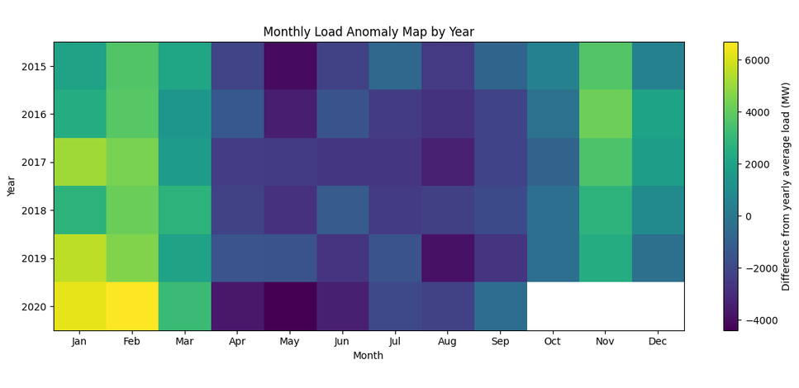
The benchmark, SARIMA, SARIMAX, and Gradient Boosting models all employed the weekly series because weekly aggregation preserves the annual seasonal pattern while reducing very short-term noise. Since the assignment calls for a neural network that uses the original hourly data, the LSTM model was handled independently. A two-year forecast horizon from October 2018 to October 2020 was provided by the weekly models, which were tested during the last 104 weeks.
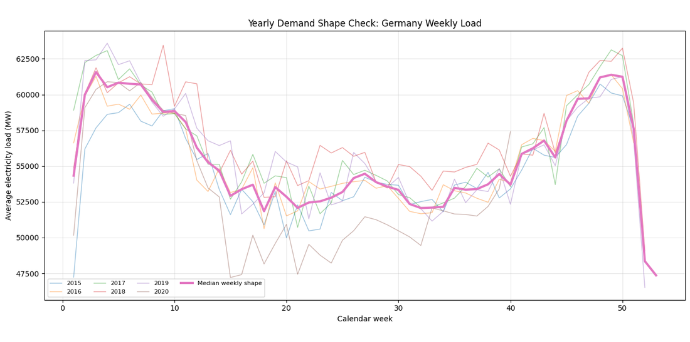
Figure 2: Monthly Average Electric Demand
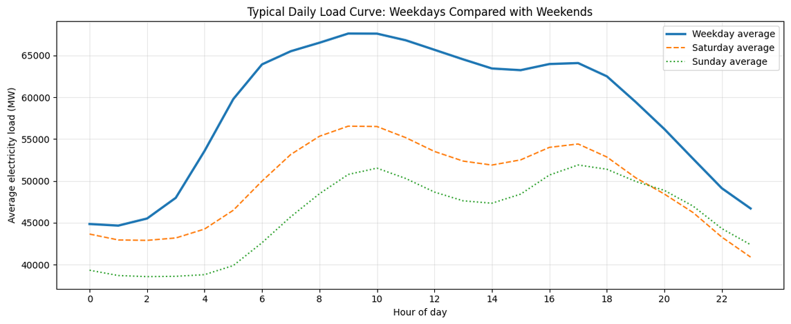
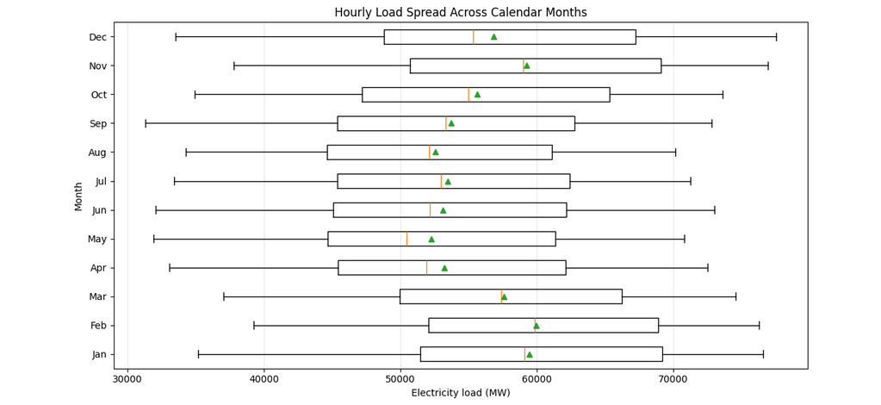
Figure 1. Weekly demand shape by calendar week.

Figure 3. Monthly spread of hourly electricity load.
Figure 4: Average Electricity Demand by Hour and Day of Week
reduced demand during warmer times and recurring winter peaks. A seasonal benchmark and a seasonal ARIMA structure were suitable as the decomposition also revealed a distinct annual component. The visual pattern indicated that values from the prior year were very relevant; weekly observations were not regarded as random independent values.
2. Modelling setup and stationarity:
Because the two tests employ distinct null hypotheses, stationarity was examined using both the ADF and KPSS tests. The level series was statistically stable because the weekly load series had an ADF p-value below 0.05 and a KPSS p-value over 0.05. Nonetheless, the decomposition and ACF/PACF graphs continued to show significant seasonal dependence. To determine whether differencing eliminated residual persistence without altering the time structure, a first difference was also examined.
Series | ADF statistics | ADF P-Value | KPSS statistic | KPSS P-Value
Weekly load | -4.047 | 0.0012 | 0.160 | 0.100
First difference | -7.069 | <0.001 | 0.056 | 0.100

Table 1. Stationarity table for the weekly demand series.

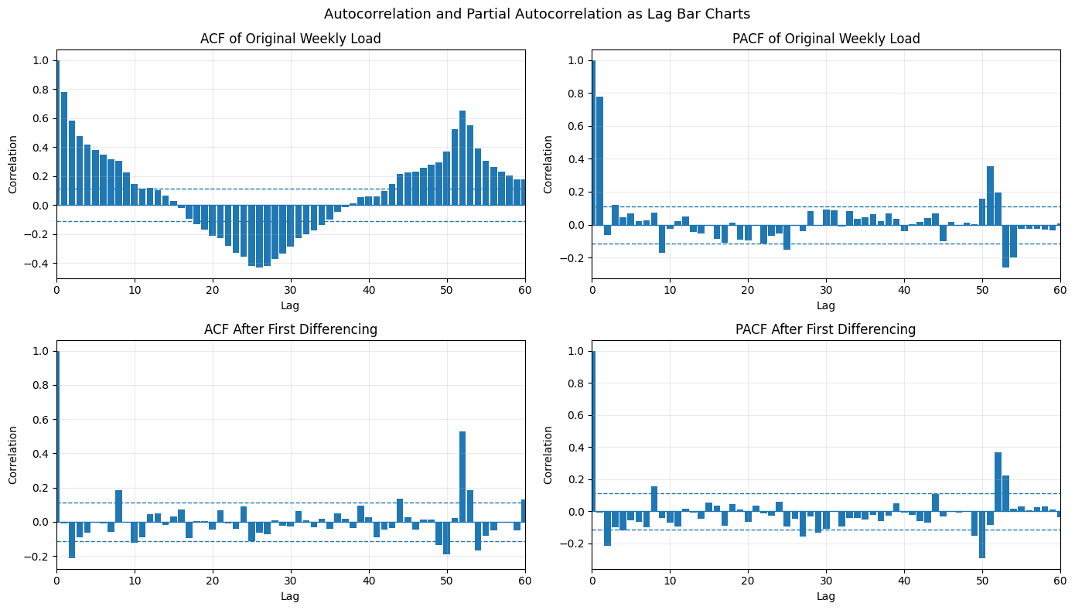
Figure 3. ACF and PACF checks before and after differencing.
The same two-year test horizon was applied to every weekly model. Because it penalizes larger errors, RMSE was chosen as the primary error metric. To make the data easier to understand, MAE and MAPE were also provided. Because it expresses the normal percentage error in relation to the electricity load level, MAPE is helpful in this situation.
3. Forecast:
The initial modelling stage was purposefully straightforward. To provide the subsequent models with a reasonable baseline to surpass, mean, naïve, seasonal naive, and drift forecasts were fitted. Because it replicates the value from the same week in the prior year, the seasonal naïve model was the best comparison.
Benchmark model | RMSE | MAE | MAPE Percentage
Seasonal naïve Forecast | 3006.76 | 2318.52 | 4.41
Mean Forecast | 4397.30 | 3788.83 | 6.97
Naïve Forecast | 4459.11 | 3783.20 | 6.79
Drift Forecast | 5117.96 | 4339.89 | 8.05

Table2: Benchmark model performance on the final 104 weeks.
With RMSE 3006.76, MAE 2318.52, and MAPE 4.41%, the Seasonal Naive forecast outperformed the Mean, Naive, and Drift forecasts across the 104-week test period, according to the benchmark models. This implies that Germany's annual electricity consumption pattern was better reflected by repeating the same week from the prior year than by using straightforward average or trend-based benchmarks.
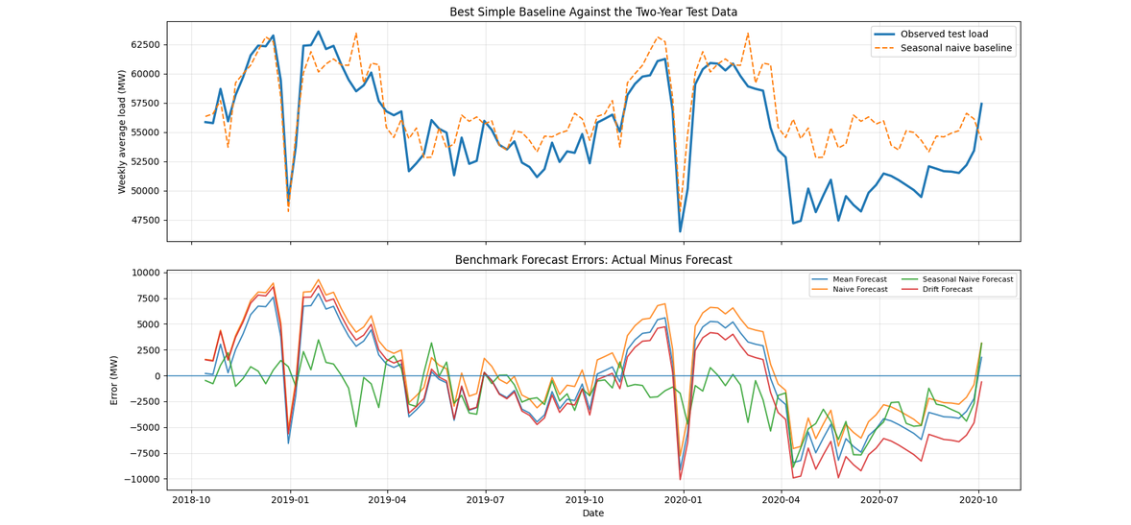
Figure 4. Benchmark forecasts and forecast errors during the test period.

4. SARIMA and SARIMAX:
The EDA revealed annual seasonality; hence a SARIMA model was constructed. AIC was used to finish the necessary grid search over p = 0 to 6, d = 0 to 2, and q = 0 to 6 over a seasonal period of 52 weeks. SARIMA (2,2,6) (1,1,1,52) was the candidate with the lowest AIC, but its two-year forecast error was extremely high showing that the best in-sample likelihood model was not the best forecasting model. This was a significant discovery: when the training set is small and the differencing order is aggressive, the model that best fits the training likelihood is not always the model that forecasts the best.
The best AIC candidates were also examined on a validation split within the training data to avoid depending just on in-sample likelihood. SARIMA (0,1,6) (1,1,1,52) was the final SARIMA specification utilised for the test forecast. Since the data were weekly and the EDA revealed yearly repetition, the seasonal period of 52 was chosen. While the seasonal difference D = 1 reflected the annual persistence seen in the ACF, the non-seasonal differencing order d = 1 was used since it performed the best in validation
After fitting the final SARIMA, residual plots, a residual histogram, and a residual ACF were examined. To determine whether significant autocorrelation persisted after modelling, residual checks were employed. The SARIMA test error was greater than the seasonal naïve benchmark in this iteration, which can be explained by the fact that some residual structure was still discernible.
Berlin weekly mean temperature and one-week lagged temperature were included as exogenous variables to the SARIMAX model. The temperature-load correlation was negative (approximately -0.65 for same-week temperature) in Berlin, which was chosen as a representative German location. Practically speaking, this association makes sense because lower temperatures are frequently linked to greater winter demand. SARIMA and the seasonal naive benchmark outperformed the SARIMAX projection, though. One possible explanation is that temperature was attempting to add information that was already captured by the seasonal structure and lagged load.
One should interpret the SARIMAX result as a conditional forecast. The test-period temperature values would not be precisely known at the actual prediction origin because they are observed historical values.
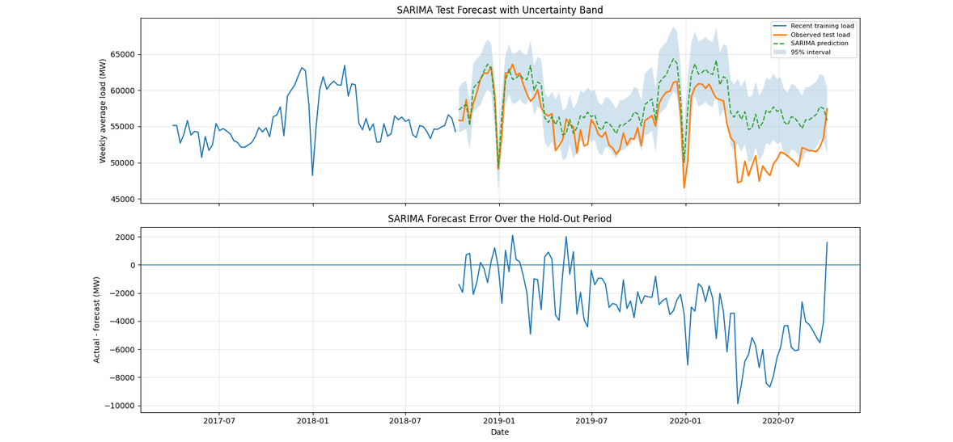
Figure 5. SARIMA forecast interval and test-period errors.
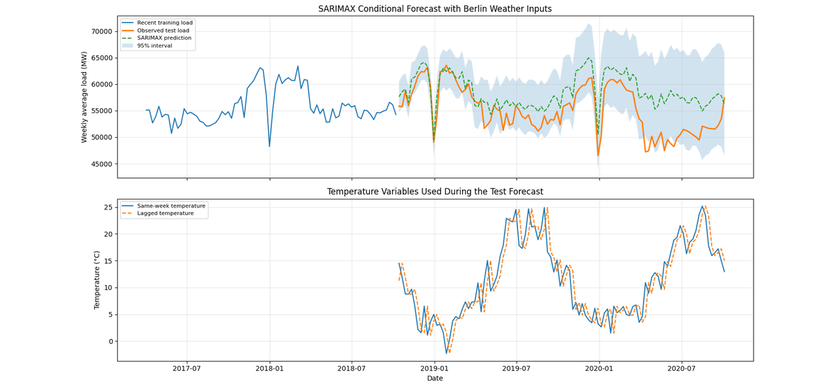
Figure 6. SARIMAX forecast with Berlin temperature inputs.
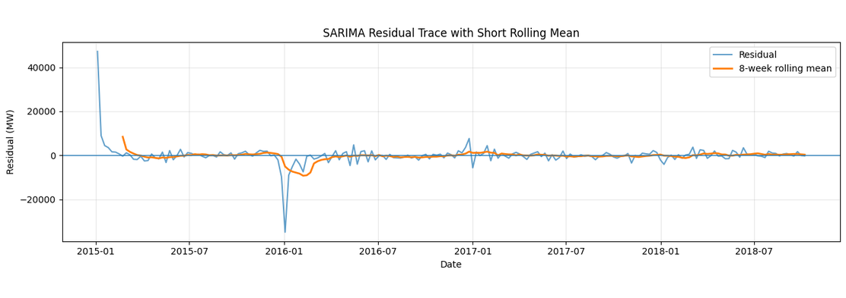
The SARIMA residuals primarily oscillate around zero over time, indicating that the model accurately depicts the weekly load series' primary trend and seasonal structure. There are still some bigger surges, though, suggesting that the model is still unable to account for abrupt shifts in the demand for electricity during odd times.
Figure 11: SARIMA Residuals Over Time:
5. Gradient Boosting model based on features:
This version has a distinct modelling emphasis because the feature-based model utilizes Gradient Boosting Regressor instead of Random Forest. Because it may incorporate lag variables, calendar cycles, and external variables without requiring linearity, gradient boosting is appropriate in this situation. One, two, four, eight, and fifty-two-week load lags, rolling means, load change, sine and cosine transformations of week/month, lagged temperature, and German public holiday indicators were among the features.
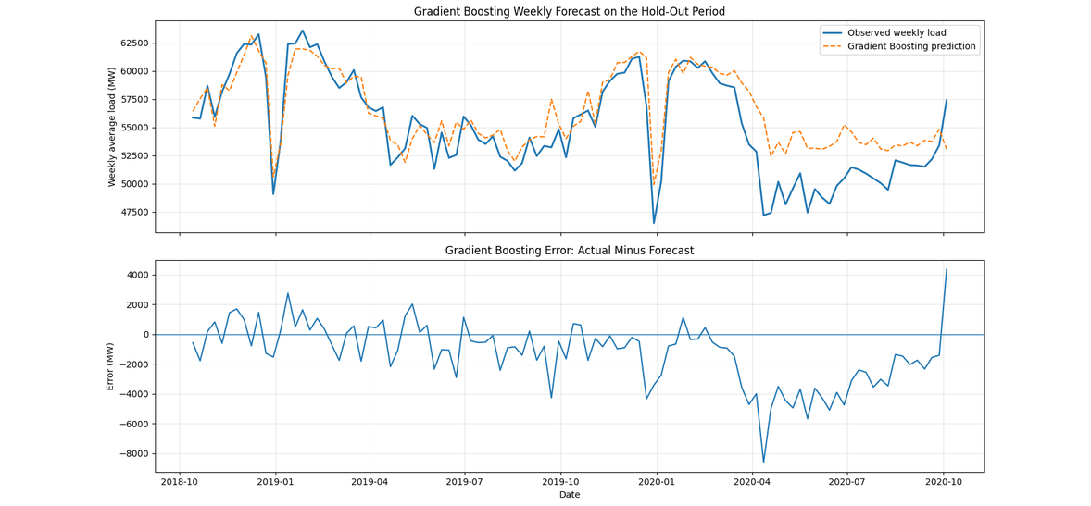
Data leaking was avoided by creating lagged characteristics only from data that was available before to the planned week. The model used temperature_lag1 rather than the same-week observed temperature. Holiday indications are safer than weather elements because the forecast origin is aware of public holiday dates in advance.
Figure 7. Gradient Boosting forecast and errors on the hold-out period.
Three feature sets were examined to see if external variables were helpful. In this tiny comparison, adding holiday information with lagged temperature produced the lowest error, however lagged temperature alone did not improve the Gradient Boosting outcome. This implies that calendar structure, as opposed to weather observations alone, is amore reliable and secure external signal.
Gradient Boosting feature set | RMSE | MAE | MAPE Percentage
Load + calendar | 2519.03 | 1900.01 | 3.62
Load + calendar + lagged temperature | 2566.41 | 1911.15 | 3.65
Load + calendar + lagged temperature + Holidays | 2384.55 | 1774.58 | 3.38

Table 3. Feature set comparison for Gradient Boosting.

6. LSTM model:
Because recurrent neural networks are made to learn temporal dependence from sequential data, the LSTM was trained on an hourly load. Because of their gated structure, which allows them to store valuable information across longer windows than a simple recurrent network, LSTM networks are frequently employed for load forecasting. To prevent leaking from the test phase, the input sequence in this study was scaled using a MinMaxScaler fitted exclusively on the training period.
One-week and two-week lookback windows, as well as one-layer versus two-layer designs, were evaluated in a brief tuning check. Overall, the validation behavior was better during the two-week lookback. The two-layer 336-hour model was retained for the final run because its validation error was extremely close and it offered greater flexibility, even though the single-layer 336-hour model had the lowest scaled validation RMSE in the small check. The final model was still assessed over the two-year test period.
LSTM | Lookback hours | Validation RMSE (scaled)
168h, 1 LSTM layer | 168 | 0.0314
336h, 1 LSTM layer | 336 | 0.0330
336h, 2 LSTM layers | 336 | 0.0309

Table 4. Small validation based on LSTM tuning check.
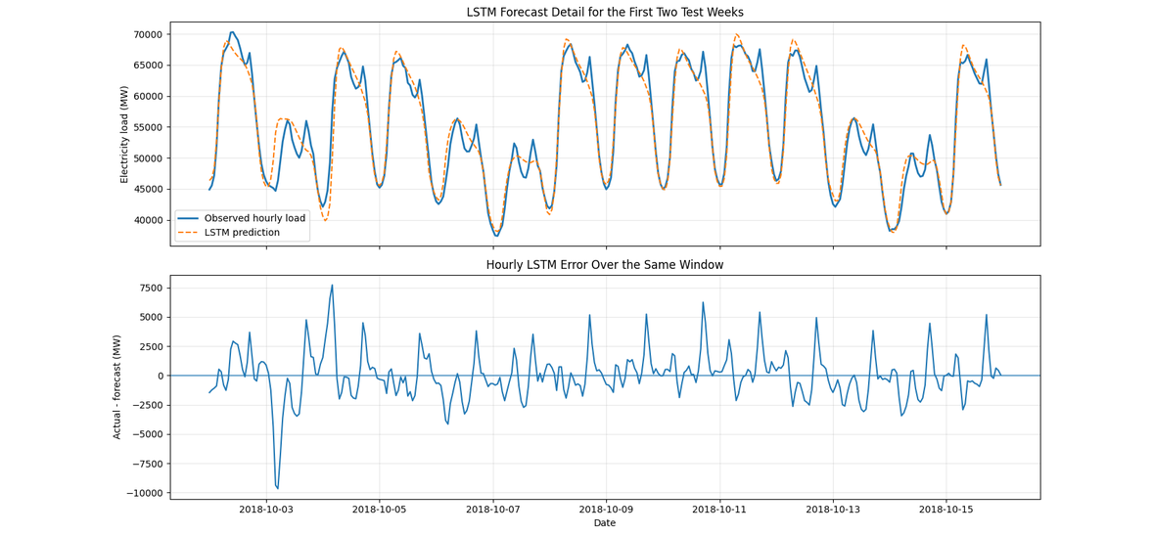
Figure 8. LSTM forecast for the first two test weeks and hourly errors.
It is not appropriate to compare the raw LSTM errors with weekly SARIMA or Gradient Boosting errors since they were computed using hourly observations The final hourly LSTM results were RMSE 1642.27, MAE 1271.52 and MAPE 2.28% . The hourly forecasts were aggregated into weekly averages, and the weekly LSTM result was RMSE 693.18, MAE 610.14, and MAPE 1.07%. This aggregate result is quite strong but should be used with caution as the LSTM has a rolling hourly set-up, unlike the same fixed weekly modelling structure as SARIMA, SARIMAX or Gradient Boosting.
7. Final comparison and recommendation:
The weekly aggregated LSTM and Gradient Boosting models improved significantly over the seasonal naïve benchmark. The MAPE improved from 4.41% to 1.07% for the weekly aggregated LSTM and 3.45% for Gradient Boosting. The hourly LSTM also performed well with MAPE 2.28%, but was tested on hourly observations, therefore should be considered independently from the weekly models. In this version, neither SARIMA nor SARIMAX beats the benchmark. This does not indicate that SARIMA is ineffective, but rather that a strong annual seasonal baseline can be hard to defeat, and that AIC-selected statistical models can suffer when structural changes arise in the test period.

Model | Frequency | RMSE | MAE | MAPE (%)
LSTM weekly aggregated | Weekly | 693.18 | 610.14 | 1.07
LSTM | Hourly | 1642.27 | 1271.52 | 2.28
Gradient Boosting | Weekly | 2397.84 | 1808.56 | 3.45
Seasonal naive benchmark | Weekly | 3006.76 | 2318.52 | 4.41
SARIMA | Weekly | 3796.12 | 3077.38 | 5.84
SARIMAX | Weekly | 4347.12 | 3515.29 | 6.69
Table 5. Final model comparison on the two-year test period.

Figure 9. Weekly models compared by MAPE on the test period.

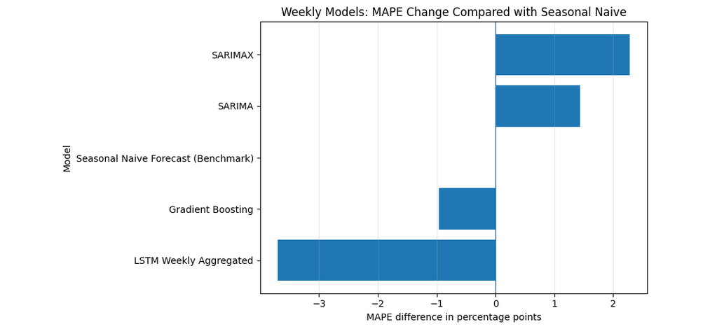
The best model depends on the objective. If only accuracy is considered, the weekly-aggregated LSTM is the clear winner. For operational use, however, I would recommend Gradient Boosting as the main model. It improves clearly over the seasonal naive benchmark, uses mostly known or lagged features, is easier to retrain than the LSTM, and gives feature importance that can be checked by an analyst. SARIMA is still useful as a transparent
reference model because it provides confidence intervals, but its accuracy was not competitive here. A practical system could therefore use Gradient Boosting for point forecasts and add uncertainty through bootstrapping, quantile regression or a SARIMA-based benchmark interval.
8.Responses to the analysis queries:
According to the questions given in the assignment and by observing my analysis:
- The best benchmark was the Seasonal Naive model with RMSE 3006.76, MAE 2318.52 and MAPE 4.41% during the 104-week span of the test data. The best numerical result was achieved using the weekly aggregated LSTM, which had MAPE about 1.07%. The hourly LSTM gave MAPE of about 2.28%. Gradient Boosting also improved weekly with a distinct MAPE of around 3.45%. Neither SARIMA nor SARIMAX models performed better than the Seasonal Naive benchmark in this iteration. Therefore, despite the significant seasonal pattern observed annually, these models had trouble generalising beyond the training period.

- When data leakage was used, temperature was carefully considered. The SARIMAX forecast is considered as a conditional forecast, not a fully operational forecast, because it used temperature values from the test period. For the feature-based model, current-week temperature was replaced with lagged temperature, since lagged values would be available at the forecast origin.

- The electricity demand series revealed a yearlong recurrence in the weekly data, hence a weekly seasonal period of 52 was used for SARIMA. The differencing order was selected by AIC-based parameter search and stationarity tests. Also, the prediction performance and residual behaviour influenced the choice of the final model although seasonal differencing was useful as annual demand patterns were very obvious.

- The potential effect of temperature and holiday conditions on electricity use was investigated. Holiday dates are known ahead of time; thus it is all right to include them in forecasting. The difference is because the future measured temperature is unknown at the prediction origin, unless it is a weather forecast. The SARIMAX model was not better than the benchmark in this iteration, however lagged temperature and holiday factors was useful in the feature-based model.

- SARIMAX is also more interpretable, as the seasonal pattern, differencing, and confidence intervals are obvious. Gradient Boosting is less transparent but can capture non-linear correlations between temperature, holidays, calendar effects and lagged load. The most complicated and hardest model to explain was LSTM, yet it delivered the strongest accuracy after weekly aggregation.

- Gradient boosting is the most balanced approach for operational use of this version. It needs less maintenance than the LSTM, performs better than the Seasonal Naive benchmark and leverages lagged or known features. If the only concern is accuracy, the best model is the weekly aggregated LSTM, although it involves additional pre-processing, tweaking and monitoring. In this run SARIMA is less accurate, but still effective for explainability and uncertainty ranges.

9. Conclusion, future work, and limitations
The primary drawback is that the test period includes 2020, a year when peculiar social and economic circumstances might have had an impact on demand patterns. The last segment of the series may therefore be more difficult for a model trained just on data from 2015 to 2018 to forecast. The fact that the temperature in Berlin is merely a stand-in for the weather experienced throughout Germany is a second drawback. The modelling of external influences could be enhanced using several regional weather stations, population-weighted temperature, and more precise calendar variables

Future research should compare Gradient Boosting with XGBoost or LightGBM, test probabilistic versions of the machine learning models, incorporate national and regional holiday indicators, and employ rolling-origin cross-validation rather than a single fixed train-test split. Further fine-tuning of the neural model could compare attention-based, CNN-LSTM, and GRU models. The primary findings from this version, however, are already evident: the greatest predictor is the annual load history; external variables are only useful when utilized cautiously; and the most accurate model is not always the most practicable model for deployment.

10.References
- Open Power System Data. (2020). Data Package Time Series. Version 2020-10-06. Available: https://doi.org/10.25832/time_series/2020-10-06

- Open-Meteo. (2026). Historical Weather API. Available at:
https://open-meteo.com/en/docs/historical-weather-api

- Hyndman, R. J. and Athanasopoulos, G. (2021). Forecasting: Principles and Practice. 3rd ed. Melbourne: OTexts. Available at:
https://otexts.com/fpp3/

- Hong, T. and Fan, S. (2016). ‘Probabilistic electric load forecasting: A tutorial review’, International Journal of Forecasting, 32(3), pp. 914–938.
https://doi.org/10.1016/j.ijforecast.2015.11.011
- Hochreiter, S. and Schmidhuber, J. (1997). ‘Long short-term memory’, Neural Computation, 9(8), pp. 1735–1780.
https://doi.org/10.1162/neco.1997.9.8.1735

